SIMATS ENGINEERING
ASSESSMENT TOOL 1

COURSE NAME: Artificial Intelligence COURSE CODE: CSA17

COURSE OUTCOME COVERED

CO1: Apply AI basics such as intelligent agents and uninformed search methods to solve problems effectively. (BL3)

Assessment Tool Weightage: 35%

QUESTIONS: 5 Duration : 1 Hour
Total Marks:50

Annexure A

Analytical Problem Solving

Code of Conduct:

I _ALLU THANMAI (192412616)_ (Name / Reg No) certify that this submission is my original work and that I have adhered to the guidelines specified for this assessment.
I understand that any violation of academic integrity rules will result in disciplinary action.

Signature of the student:

ALLU THANMAI

Annexure A

Analytical Problem Solving

- Solve the Water Jug problem: you are given 2 jugs, a 4-gallon one and 3-gallon one. Neither has any measuring maker on it. There is a pump that can be used to fill the jugs with water. How can you get exactly 2 gallons of water into 4-gallon jug? Explicit assumptions: A jug can be filled from the pump, water can be poured out of a jug onto the ground, water can be poured from one jug to another and that there are no other measuring devices available.

ANSWER:
Water Jug Problem
Given
Jug A = 4 gallons

Jug B = 3 gallons

No measurement markings

Goal = Get exactly 2 gallons in the 4-gallon jug

Initial State
(A,B)=(0,0)
A. Problem Understanding – 20%
We are given two unmarked jugs:

Jug A = 4 gallons

Jug B = 3 gallons
Unlimited water is available from a pump.
Water can be poured between the jugs or thrown away.
No other measuring device is available.
Objective: Obtain exactly 2 gallons in the 4-gallon jug.
State Representation
(A,B)
where A represents the amount of water in the 4-gallon jug and B represents the amount in the 3-gallon jug.
Initial state:
(0,0)
Goal state:
(2,0)

B. Method Selection – 20%
The appropriate method is State-Space Search.
Each pair (A,B) represents a state, and each legal operation produces a new state.
Allowed operations:
Fill a jug.
Empty a jug.
Pour one jug into another.

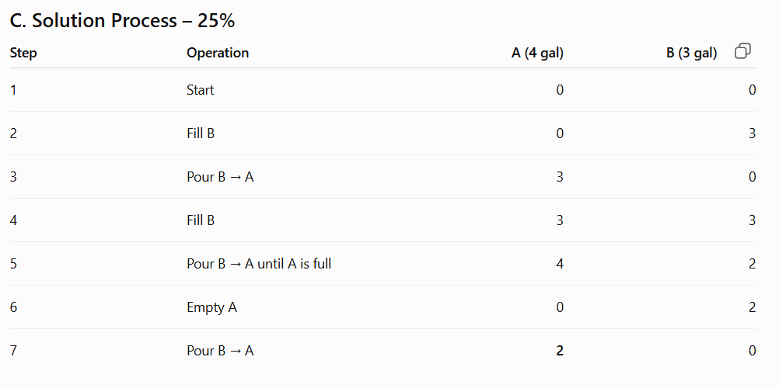
D. Accuracy of Calculation – 20%
After the final operation:

A=2,B=0
Therefore,
Water in 4-gallon jug=2 gallons
​

- Find out how Mars Rover, analyse and explore the samples on Mars by answering the following questions.
- What are the percept’s for this agent?
- Characterize the operating environment.
- What are the actions the agent can take?
- How can one evaluate the performance of the agent?
- What sort of agent architecture do you think is most suitable for this agent? Why?

A. Problem Understanding – 20%
A Mars Rover is an intelligent agent designed to observe, explore and analyse the Martian surface. It collects samples, avoids obstacles and sends scientific information to Earth.
The rover must make decisions despite having incomplete information about its surroundings.

B. Method Selection – 20%
The rover can be modelled using the PEAS framework:

P – Performance measure

E – Environment

A – Actuators

S – Sensors

This framework is suitable for identifying the requirements of an intelligent agent.

C. Solution Process – 25%
i. Percepts of the Agent
The rover receives the following percepts through its sensors:

Images of Mars
Distance from obstacles
Terrain information
Temperature
Atmospheric conditions
Soil and rock properties
Chemical composition
Location and orientation
Battery level
Communication status

| Property | Mars Rover |
| ------------------------ | -------------------- |
| Observability | Partially observable |
| Deterministic/Stochastic | Stochastic |
| Episodic/Sequential | Sequential |
| Static/Dynamic | Dynamic |
| Discrete/Continuous | Continuous |
| Number of agents | Single agent |
| Known/Unknown | Partially unknown |

iii. Actions of the Agent
The rover can:
Move forward.
Move backward.
Turn left/right.
Stop.
Capture images.
Scan rocks.
Drill soil.
Collect samples.

iv. Performance Evaluation
The rover can be evaluated based on:
Distance explored
Number and quality of samples collected

Scientific information obtained
Navigation accuracy
Obstacles avoided
Energy consumption
Communication reliability

v. Suitable Agent Architecture
A Model-Based Goal-Based Learning Agent is most suitable.

Reason: The rover operates with incomplete information. It needs an internal model of the environment, specific goals such as collecting samples, and the ability to improve its decisions based on previous experiences.

D. Accuracy – 20%
The classification is:

Partially Observable + Stochastic + Sequential + Dynamic + Continuous
Suitable architecture:
Model-Based Goal-Based Learning Agent
​

E. Interpretation – 15%
Therefore, a model-based goal-based learning agent is suitable because it can observe its surroundings, maintain information about previously explored areas, make decisions toward scientific goals and adapt to uncertain Martian conditions.

- Explore the search space using search strategies and formulate the problem components for the 8-Queens problem using the following information: Place 8 queens on a chessboard such that none of the queen’s attack any of the others. A configuration of 8 queens on the board as shown in the figure below, but this does not represent a solution as the queen in the first column is on the same diagonal as the queen in the last column.

A. Problem Understanding – 20%
The objective is to place 8 queens on an 8 × 8 chessboard such that no two queens attack each other.
Two queens must not be in:
Same row
Same column
Same diagonal

B. Method Selection – 20%
The suitable method is Backtracking using Depth-First Search (DFS).
Backtracking is effective because whenever a queen creates a conflict, that position can be rejected and the algorithm can return to the previous decision.

C. Problem Components
Initial State
No queens are placed.

State
A partial arrangement of queens on the chessboard.

Actions
Place a queen in an empty position that does not conflict with previously placed queens.

Goal Test
All 8 queens are placed and no two queens attack each other.

Path Cost
Each queen placement can be considered as cost 1.

D. Solution Process – 25%
One valid solution is:

[1,5,8,6,3,7,2,4]
​
Here, each number represents the row position of the queen in each column.

Column: 1 2 3 4 5 6 7 8
Row: 1 5 8 6 3 7 2 4

Backtracking Process :

Start
↓
Place Queen 1
↓
Place Queen 2
↓
Check conflict
↓
If conflict → Backtrack
↓
Try another position
↓
Continue until 8 queens placed
↓
Goal reached

E. Accuracy – 20%
For the solution:

[1,5,8,6,3,7,2,4]
No two queens share the same row, column or diagonal.

Therefore, it is a valid solution.

F. Interpretation – 15%
The 8-Queens problem is a Constraint Satisfaction Problem (CSP). Backtracking efficiently explores possible configurations while rejecting configurations that violate the constraints.

- A customer wants to travel from the one location to another location using OLA Cab booking mobile application. The customer can select the any of the cab type as mini, micro, sedan, shared, prime and so on based on his comfort to reach the destination. Identify what type of problem-solving agent can be used and write the pseudocode for the above problem.

A. Problem Understanding – 20%
A customer wants to travel from a source location to a destination using a cab booking application.

Different cab options are available, such as:

Micro
Mini
Sedan
Prime
Shared
The customer may consider fare, comfort, travel time and availability.

B. Method Selection – 20%
The appropriate agent is a:

Utility-Based Agent
​
Reason
A utility-based agent compares different choices and selects the option that provides the highest overall utility according to the customer's requirements.

C. Problem Components – 25%
Initial State
Customer is at the source location.

Goal State
Customer reaches the destination.

Actions
Enter source.
Enter destination.
Search available cabs.
Display cab types.
Calculate fare.
Estimate travel time.

- Pseudocode
BEGIN

Input Source
Input Destination

Find available cabs

FOR each available cab

Get cab type
Get fare
Get travel time
Get comfort level
Get availability

Calculate utility

END FOR

Select cab with highest utility

Display selected cab

IF customer confirms THEN

Book cab
Track cab
Start journey
Navigate to destination
Complete trip

ELSE

Select another cab

END IF

END

E. Accuracy – 20%
The agent considers multiple factors rather than only the distance.

For example:

Utility=f(Cost,Comfort,Time,Availability)
The cab having the highest utility is selected.

F. Interpretation – 15%
A utility-based agent is the best choice because it can balance cost, comfort, travel time and availability and recommend the most suitable cab for the customer.

- A logistics company operates a delivery network where packages must be transported between warehouses at minimum cost. Each route between warehouses has an associated travel cost (fuel + time). The company wants to determine the least-cost path from the starting warehouse S to the destination warehouse G using the Uniform Cost Search (UCS) algorithm.

The delivery network is represented as a weighted graph:
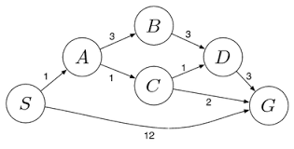

A. Problem Understanding – 20%
The logistics company wants to transport a package from:

S=Starting Warehouse
​

to

G=Destination Warehouse
​

Each route has a different cost representing fuel and travel time.

Objective
Find the path from S to G having minimum total cost.

B. Method Selection – 20%
The suitable algorithm is:

Uniform Cost Search (UCS)
​

Why UCS?
UCS is suitable because the graph contains different path costs.

UCS always expands the node with the lowest cumulative cost from the starting node.

C. Solution Process – 25%
Step 1
Start with:

Cost(S)=0
Step 2
Place S in the priority queue.

Priority Queue = [(S, 0)]
Step 3
Expand the node with the lowest cumulative cost.

Step 4
Calculate:

New Cost=Current Cost+Edge Cost
Step 5
Add the new paths to the priority queue.

Step 6
Again select the path with the smallest cumulative cost.

Step 7
Continue until G is selected.

UCS Pseudocode

UCS(S, G)

PriorityQueue ← (S, 0)

WHILE PriorityQueue is not empty

Remove node with minimum cumulative cost

IF node = G THEN
Return path and total cost
END IF

FOR each neighbor of node

NewCost =
CurrentCost + EdgeCost

Add neighbor with NewCost
to PriorityQueue

END FOR

END WHILE

D. Accuracy of Calculation – 20%
For every possible path:

Total Cost=∑Route Costs
​

UCS selects the path with the smallest total cost.

For example, if a path is:

S→A→B→G
with costs:

4+3+5
then:

Total Cost=12
This value must be compared with the costs of other possible paths.

E. Interpretation – 15%
The path selected by UCS is the least-cost route from S to G. This helps the logistics company reduce total transportation cost while selecting the most economical route.

Final Answer Format
S→Intermediate Warehouses→G
​

Minimum Total Cost=sum of route costs
​

RUBRICS FOR CALCULATION:
Criteria | Weightage | Level 4 (Exemplary) | Level 3 (Proficient) | Level 2 (Developing) | Level 1 (Beginning)
Problem Understanding | 20% | Clearly interprets problem, identifies all parameters and requirements accurately | Understands problem with minor gaps | Partial understanding; misses key elements | Misinterprets or unable to understand problem
Method Selection | 20% | Selects most appropriate method/formula with strong justification | Selects correct method with minor errors | Inappropriate or partially correct method | Unable to select method
Solution Process | 25% | Logical, systematic steps with correct approach throughout | Mostly correct steps with minor mistakes | Disorganized steps; multiple errors | No clear process
Accuracy of Calculation | 20% | All calculations accurate; correct final answer | Minor calculation errors | Frequent errors; incorrect final answer | No valid calculations
Interpretation of Results | 15% | Clearly interprets results with units and engineering relevance | Basic interpretation with minor omissions | Limited or unclear interpretation | No interpretation
Problem Understanding | 20% | Clearly interprets problem, identifies all parameters and requirements accurately | Understands problem with minor gaps | Partial understanding; misses key elements | Misinterprets or unable to understand problem

